Working Group Leader Guide
2026 SAEM Consensus Conference
Artificial Intelligence and Emergency Medicine: Technology, Training, Self, and Society
May 21, 2026 | Atlanta Marriott Marquis | Atlanta, GA

First, thank you. You have agreed to co-lead a working group on an ambitious timeline, and we don't take that lightly. We have about ten weeks of pre-conference work ahead, starting with two weeks to recruit your group, and we've designed this process to be as efficient as possible while still producing something meaningful.
This document covers everything you need: what we're asking of you, how the process works, key dates, and where you can get help. Please read it through before your kickoff meeting. If something doesn't make sense or doesn't work for your group, let's talk about it.
Andrew Taylor | Conference Chair | kqc5mk@uvahealth.org

The Big Picture
We are building a 10-year research agenda for AI in emergency medicine. Your working group is responsible for one piece of that agenda. Through a modified Delphi process, your group will identify and reach consensus on the most important research questions in your domain. Those questions come to the full conference on May 21, where ~175 attendees will discuss, refine, and prioritize them alongside the other groups' work. The combined output gets published in Academic Emergency Medicine as the conference proceedings.
Your group's deliverable is straightforward: a consensus-driven list of research questions that are specific enough to guide grant proposals and rigorous enough to hold up in a peer-reviewed publication.

What We're Asking of You
Each working group will ideally have two co-leads who share the responsibilities below. If your group has a single lead, the planning committee will provide extra support. Between the co-leads, you are responsible for:
- Recruiting your working group members (see below)
- Facilitating three virtual meetings (about 2-3 hours total meeting time)
- Guiding the development and refinement of your group's research questions
- Running two Delphi survey rounds (we'll help with setup)
- Submitting a 2-page summary of your group's work by May 14
- Presenting your findings on conference day and facilitating breakout discussion
How you divide the work is up to you. One approach: one co-lead takes point on the pre-conference process (meetings, Delphi surveys) while the other focuses on the conference-day presentation and breakout facilitation. But whatever works for your schedules is fine.
Realistically, expect a total time commitment of roughly 10-15 hours spread across the ten weeks, including recruitment, meetings, async coordination, and document prep. The planning committee handles scheduling, survey logistics, and formatting.
Here's how the full process fits together:
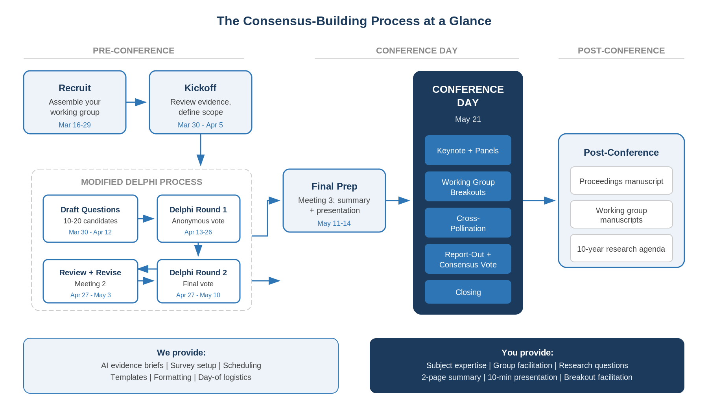

Assembling Your Working Group
Each working group will ideally have two co-leads and 8-10 members. Having two co-leads ensures coverage if one of you has a conflict, and splits the workload for meetings, Delphi administration, and the conference-day presentation. If your group has a single lead, that works too, but we encourage you to identify a co-lead from your network or from the members you recruit.
You have two weeks (March 16-29) to recruit your group. Please have your roster finalized and sent to Hope Duncan by March 29 so we can schedule kickoff meetings for the week of March 30.

Who to recruit
Look for people who bring different angles to your topic. A strong group typically includes:
- At least one person with deep subject matter expertise in your domain
- At least one active clinical emergency physician who can ground the discussion in ED reality
- Someone with methodological or technical expertise relevant to your area (e.g., informatics, data science, education research, health services research, legal/policy)
- At least one early-career member (fellow, junior faculty, or senior resident with relevant experience)
- Diversity of institution, geography, gender, and background

Where to look
Your own professional network is the obvious starting point. Beyond that:
- SAEM interest groups and academies (especially Informatics, Education, and Research)
- Authors of key papers in your domain
- Colleagues you've worked with at conferences, on committees, or in prior collaborations
- The planning committee can suggest names if you need help filling a gap

What to tell recruits
Be upfront about the commitment. Not every member needs to attend every meeting, but they should expect:
- Three virtual meetings (kickoff, mid-point, final prep) totaling about 2 hours; attendance at the kickoff is strongly encouraged
- Asynchronous work between meetings: reviewing evidence, drafting questions, completing two brief Delphi surveys
- Roughly 5-8 hours total over eight weeks
- The opportunity to shape a national research agenda that will be published in AEM
Authorship: Working group leaders and members who actively participate will be included on individual working group manuscripts. The conference co-chairs will advocate for group authorship on the proceedings manuscript, though this is subject to journal policy.

Let us know
Once your group is set, send the list of names, affiliations, and email addresses to Hope Duncan so we can add them to communications and set up meetings.

Timeline
Here's the full schedule, week by week. The Gantt chart gives you the shape at a glance; the detail table below spells out each step.

At a Glance
 | 3/16 | 3/23 | 3/30 | 4/6 | 4/13 | 4/20 | 4/27 | 5/4 | 5/11 | 5/18
Leader confirmed; review materials
Recruit working group members
Meeting 1: Kickoff
Draft research questions (async)
Delphi Round 1 survey
Meeting 2: Review Round 1 results
Delphi Round 2 survey
Meeting 3: Final prep
2-page summary due
Planning committee review
Summaries to attendees
Conference Day (May 21)

Week by Week
Dates | What happens
March 16-22 | Leaders confirmed. Planning committee distributes this guide, working group descriptions, and AI-generated evidence briefs. Leaders begin reviewing materials and identifying potential working group members.
March 23-29 | Recruitment continues. Leaders finalize working group membership (8-10 members per group). Send member names and emails to Hope Duncan by end of week.
Mar 30 - Apr 5 | Meeting 1 (Kickoff): Review scope, discuss evidence brief, assign roles, brainstorm initial research questions. Begin asynchronous question development after the meeting.
April 6-12 | Asynchronous work continues. Groups develop initial list of 10-20 candidate research questions via email, shared docs, or brief calls as needed. Leaders compile and organize the list.
April 13-26 | Delphi Round 1 survey distributed to all working group members. Anonymous rating of each question (include / include with modifications / exclude) plus free-text comments. Allow 10-14 days for responses.
Apr 27 - May 3 | Meeting 2 (Mid-point): Review Round 1 results. Discuss questions with mixed ratings. Revise, merge, or add questions. Distribute Delphi Round 2 survey. Round 2 open through May 10.
May 4-10 | Delphi Round 2 closes. Leaders compile final results. Questions reaching 80%+ inclusion are confirmed. Questions below 20% are removed.
May 11-14 | Meeting 3 (Final prep): Finalize consensus question list. Complete 2-page summary. Prepare 10-minute conference presentation. Submit summary to planning committee.
May 14-17 | Planning committee reviews summaries for overlap and completeness. Final summaries distributed to all registered conference attendees. SAEM Annual Meeting begins May 17.
May 18-21 | Conference week. Consensus Conference Day is Thursday, May 21. Presentations, breakout discussions, cross-pollination, and consensus voting.

The Three Meetings
All meetings are virtual (Zoom). Hope will coordinate scheduling with your group. Keep them tight; we've suggested time ranges below, but shorter is fine if you cover the ground.

Meeting 1: Kickoff (March 30 - April 5, 45-60 min)
This is the one meeting you really can't rush. Agenda:
- Introductions and roles. Who's doing what. Decide who will present on conference day.
- Walk through your working group description. Make sure everyone understands the scope and boundaries.
- Discuss the AI-generated evidence brief (see below). What rings true? What's missing? What surprised you?
- Start generating candidate research questions. You won't finish here, but get the conversation going.
- Agree on how you'll work between meetings (email thread, shared Google Doc, Slack channel, etc.).

Meeting 2: Mid-Point (April 27 - May 3, 30-45 min)
- Review the Delphi Round 1 results together. Where did the group agree? Where did it diverge?
- Focus discussion on questions that got mixed ratings or substantive written comments.
- Revise wording, merge overlapping questions, add any new ones that emerged.
- Finalize and distribute the Round 2 survey before the meeting ends (or within a day or two).

Meeting 3: Final Prep (May 11-14, 30-45 min)
- Review Round 2 results. Lock in the final consensus list.
- Walk through the 2-page summary draft. Make edits together or assign a clean-up pass.
- Plan the conference-day presentation: what to highlight, what story to tell, who presents.
- Discuss how you'll facilitate the breakout session on May 21 (what questions to pose to the room, how to capture feedback).

The Evidence Brief
We're doing the literature review differently than past consensus conferences, and it's intentional.
Instead of asking each group to spend weeks screening abstracts through Covidence, the planning committee will provide each working group with an AI-generated evidence brief. These will be produced using AI-assisted literature synthesis, then reviewed by our research librarian and the planning committee before they reach you.
Each brief will include:
- A structured overview of the current evidence landscape for your domain
- Key themes and findings from the existing literature
- Identified gaps where evidence is thin or absent
- A curated reference list of high-impact papers
Think of the brief as a head start, not a final product. Your group's expertise is what validates, corrects, and extends it. We expect you to push back on what the AI gets wrong, add what it misses, and use it as a springboard for generating research questions rather than as a definitive review.
There's also a certain appropriateness to this approach for a conference on AI in medicine. We're using the technology we've convened to study.

The Modified Delphi Process
The Delphi method builds consensus through iterative anonymous surveys. We're using two rounds (compressed from the traditional three) to fit our timeline. Here's how it works.

Step 1: Generate Candidate Questions (March 30 - April 12)
After the kickoff meeting, your group develops an initial list of 10-20 candidate research questions. You have about two weeks for this. Draw on the evidence brief, your group's expertise, the suggested topics in your working group description, and consideration of equity and priority populations.
A good Delphi question is specific, empirically testable, and actionable. The test: could someone write a grant proposal around this question? If the answer is no, sharpen it.

Step 2: Delphi Round 1 (April 13-26)
Distribute an anonymous survey to all group members. For each question, respondents rate:
- Include this in the research agenda
- Include with modifications (with space to suggest changes)
- Exclude this from the research agenda
Include an open section at the end for new question suggestions and general comments. We can help you set this up in Google Forms, Qualtrics, or SurveyMonkey.

Step 3: Review and Revise (April 27 - May 3, at Meeting 2)
Look at the results together. Discuss the close calls. Revise wording where the "modify" votes point to real improvements. Add new questions if Round 1 surfaced something important. Then send out Round 2.

Step 4: Delphi Round 2 (April 27 - May 10)
Same format, but this time respondents see the Round 1 voting percentages alongside each question. This gives everyone a sense of where the group stands and tends to move borderline questions toward resolution.

Consensus Thresholds
Result | Action
80%+ inclusion | Confirmed. Question goes on the final list.
21-79% inclusion | Discuss among leaders. If consensus can't be reached, note the question but don't include it in the primary list.
20% or below | Removed.
Track the percent agreement for each question at each round. This data goes in the proceedings manuscript.

Deliverables

1. Two-Page Summary (due May 14)
A concise document that includes:
- Brief overview of your group's domain
- Summary of the evidence landscape (drawing from the evidence brief and your group's expertise)
- Key gaps or recommendations
- Final list of consensus research questions with percent agreement for each
The planning committee will provide a template. These summaries get reviewed for overlap between groups, then distributed to all registered attendees by May 17 so people arrive prepared.

2. Conference-Day Presentation (May 21)
A 10-minute presentation to the full conference. Cover the highlights: what your group found, where the evidence is strong, where the gaps are, and what research questions reached consensus. You'll also facilitate a breakout discussion where attendees weigh in on your questions and may suggest additions or modifications.

3. Post-Conference Manuscript
Each group's findings get folded into the conference proceedings manuscript for Academic Emergency Medicine. You'll review and approve your section. Individual groups are also encouraged to develop standalone manuscripts based on the full Delphi results and literature review.

Conference Day: May 21
The full agenda will be shared separately, but here's what to expect as a group leader:
- Morning keynote and panels set the context for all attendees.
- Breakout sessions (you'll run yours): present findings, facilitate discussion, capture feedback from attendees who join your group.
- Cross-pollination: your group pairs with another to explore intersections. Think about what overlaps or tensions exist between your domain and others.
- Report-out and voting: each group presents final recommendations to the full room. The audience prioritizes across all groups.
Your main jobs are presenting clearly, facilitating good discussion, and being open to what the broader audience brings. The planning committee handles logistics, AV, and timekeeping.

Planning Committee
We're here to help. Reach out for anything.
Name | Role | Institution
Andrew Taylor, MD MHS | Conference Chair | University of Virginia
Moira Smith | Planning Committee | University of Virginia
Andrew Muck | Planning Committee | University of Virginia
Thomas Hartka | Planning Committee | University of Virginia
Matt Trowbridge | Planning Committee | University of Virginia
Hope Duncan | Administrative Support | University of Virginia

Questions? Email Andrew Taylor at kqc5mk@uvahealth.org or call/text anytime.

